Week 3
MongoDB Connectivity

- Download MongoDB Compass and Community server using the following links and install.
MongoDB Compass: https://www.mongodb.com/try/download/terraform-provider
Community Server: https://www.mongodb.com/try/download/community
- After installation, open powershell and check connectivity using
> Get-Service MongoDB
3. If service is not running, type “Start-Service MongoDB”
4. Open MongoDB Compass and Create a database named llm_monitoring and then create collection named call_logs.
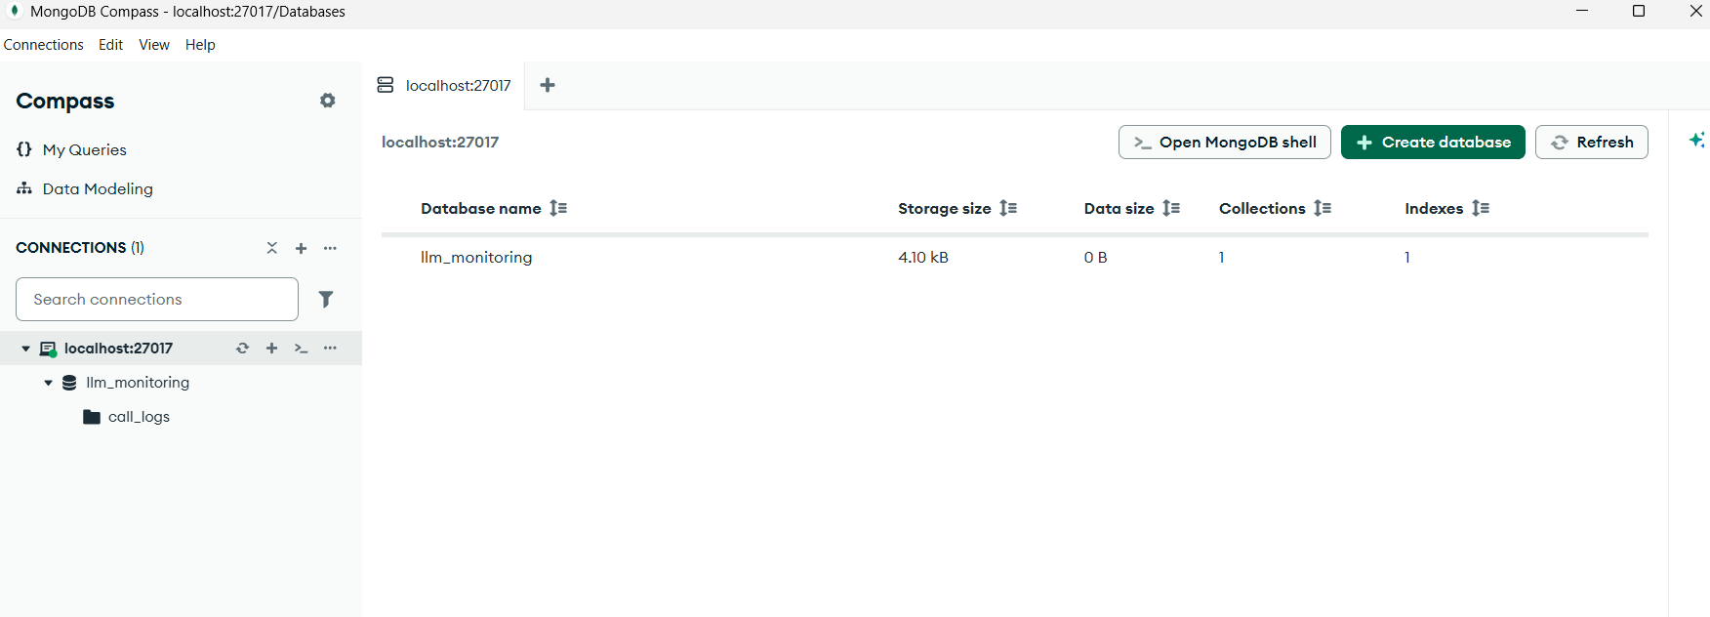
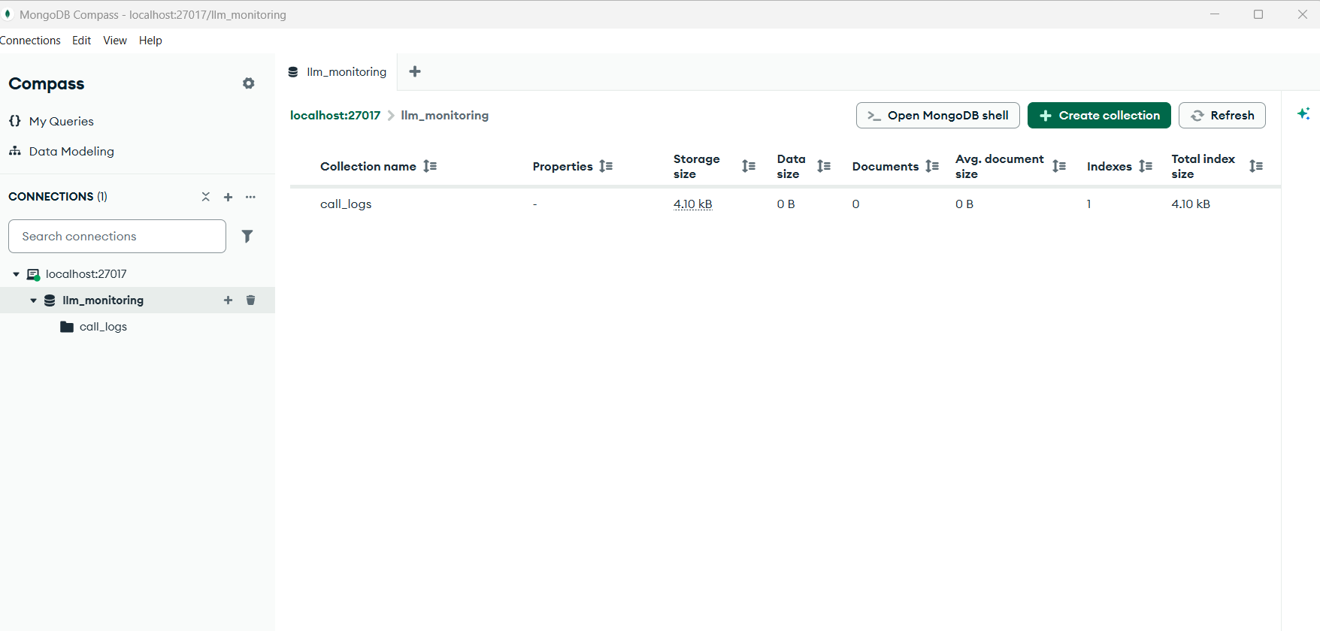
5. Open powershell and pull Ollama model as > ollama pull llama3.2
> ollama run llama3.2
6. Open vscode and create Week-3. Add below files.
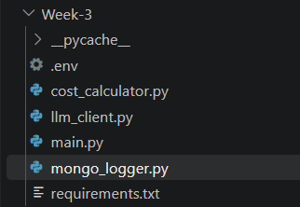
cost_calculator.py
# cost_calculator.py

# Example rates per 1 million tokens.
# IMPORTANT: These are sample values, not verified current Gemini prices.
# Replace them with the actual rates for your selected model.

PRICING = {
"gemini-3.8-flash": {
"input": 0.50,
"output": 2.00
}
}

def calculate_cost(provider, model, input_tokens, output_tokens):

# Ollama runs locally and does not charge a per-token API fee.
if provider == "OllamaProvider":
return 0.0

rates = PRICING.get(model)

if rates is None:
return None

input_cost = (
input_tokens * rates["input"]
) / 1_000_000

output_cost = (
output_tokens * rates["output"]
) / 1_000_000

total_cost = input_cost + output_cost

return round(total_cost, 10)

llm_client.py
# llm_client.py

from abc import ABC, abstractmethod
from google import genai
from google.genai import types
import requests
import time

from cost_calculator import calculate_cost

# --------------------------------
# 1. Common LLM Provider Interface
# --------------------------------

class LLMProvider(ABC):

@abstractmethod
def generate(self, prompt):
pass

# --------------------------------
# 2. Gemini Provider
# --------------------------------

class GeminiProvider(LLMProvider):

def __init__(self, api_key):

self.client = genai.Client(
api_key=api_key,
http_options=types.HttpOptions(timeout=30000)
)

self.model = "gemini-3-flash-pro"

def generate(self, prompt):

response = self.client.models.generate_content(
model=self.model,
contents=prompt
)

usage = response.usage_metadata

input_tokens = (
usage.prompt_token_count if usage else 0
)

output_tokens = (
usage.candidates_token_count if usage else 0
)

return {
"response": response.text,
"input_tokens": input_tokens,
"output_tokens": output_tokens
}

# --------------------------------
# 3. Ollama Provider
# --------------------------------

class OllamaProvider(LLMProvider):

def __init__(self, model="llama3.2"):

self.model = model

self.url = "http://localhost:11434/api/generate"

def generate(self, prompt):

response = requests.post(
self.url,
json={
"model": self.model,
"prompt": prompt,
"stream": False
},
timeout=30
)

response.raise_for_status()

data = response.json()

return {
"response": data["response"],
"input_tokens": data.get("prompt_eval_count", 0),
"output_tokens": data.get("eval_count", 0)
}

# --------------------------------
# 4. Common LLM Client
# --------------------------------

class LLMClient:

def __init__(self, provider, logger):

self.provider = provider

self.logger = logger

def generate(self, prompt):

max_attempts = 3

start_time = time.perf_counter()

last_error = None

for attempt in range(1, max_attempts + 1):

try:

# Generate AI response
result = self.provider.generate(prompt)

# Calculate total elapsed time, including retries
latency = round(
(time.perf_counter() - start_time) * 1000,
2
)

input_tokens = result["input_tokens"]

output_tokens = result["output_tokens"]

model = self.provider.model

provider_name = type(self.provider).__name__

cost = calculate_cost(
provider_name,
model,
input_tokens,
output_tokens
)

# Prepare MongoDB document
log_data = {
"provider": provider_name,
"model": model,
"prompt": prompt,
"input_tokens": input_tokens,
"output_tokens": output_tokens,
"total_tokens": input_tokens + output_tokens,
"latency_ms": latency,
"cost": cost,
"attempts": attempt,
"status": "success",
"error": None
}

# Log separately: a MongoDB error must not repeat
# an already successful model request.
try:
self.logger.log_call(log_data)
except Exception as log_error:
print("MongoDB logging error:", log_error)

return result["response"]

except Exception as error:

last_error = error

# Retry only likely temporary failures
status_code = getattr(error, "status_code", None)

retryable = (
isinstance(
error,
(requests.exceptions.Timeout,
requests.exceptions.ConnectionError)
)
or status_code == 429
or (
isinstance(status_code, int)
and status_code >= 500
)
or (
isinstance(error, requests.exceptions.HTTPError)
and error.response is not None
and (
error.response.status_code == 429
or error.response.status_code >= 500
)
)
)

if not retryable or attempt == max_attempts:
break

wait_time = 2 ** (attempt - 1)

print(
f"Attempt {attempt} failed. "
f"Retrying in {wait_time} seconds..."
)

time.sleep(wait_time)

# All attempts failed, or the error was not retryable
latency = round(
(time.perf_counter() - start_time) * 1000,
2
)

failed_log = {
"provider": type(self.provider).__name__,
"model": self.provider.model,
"prompt": prompt,
"latency_ms": latency,
"attempts": attempt,
"status": "failed",
"error": str(last_error)
}

try:
self.logger.log_call(failed_log)
except Exception as log_error:
print("MongoDB logging error:", log_error)

raise last_error

main.py
# main.py

import os

from dotenv import load_dotenv

from llm_client import (
GeminiProvider,
OllamaProvider,
LLMClient
)

from mongo_logger import MongoLogger

# Load environment variables
load_dotenv(override=True)

print("================================")
print(" WEEK 3: LLM MONITORING")
print("================================")

print("1. Gemini")
print("2. Ollama")

choice = input("\nSelect provider (1/2): ").strip()

logger = None

try:

# Connect to MongoDB
logger = MongoLogger()

# Select AI provider
if choice == "1":

api_key = os.getenv("GEMINI_API_KEY")

if not api_key:
raise ValueError("Gemini API key not found in .env")

provider = GeminiProvider(api_key)

elif choice == "2":

provider = OllamaProvider("llama3.2")

else:

raise ValueError("Invalid selection. Choose 1 or 2.")

# Create common client
client = LLMClient(provider, logger)

# Get user prompt
prompt = input("\nEnter your question: ")

# Generate response
answer = client.generate(prompt)

print("\n========== AI RESPONSE ==========")

print(answer)

print("\n========== COMPLETED ==========")

except Exception as error:

print("\nApplication error:", error)

finally:

if logger is not None:
logger.close()

mongo_logger.py

from pymongo import MongoClient
from datetime import datetime, timezone

class MongoLogger:

def __init__(self):

self.client = MongoClient(
"mongodb://localhost:27017/"
)

self.db = self.client["llm_monitoring"]

self.collection = self.db["call_logs"]

def log_call(self, log_data):

log_data["timestamp"] = datetime.now(timezone.utc)

self.collection.insert_one(log_data)

print("Call details saved in MongoDB!")

def close(self):

self.client.close()

def close(self):

self.client.close()

requirements.txt
pytest
google-genai
python-dotenv
pymongo

.env
GEMINI_API_KEY="API KEY give her….."

7. python main.py


